The Hook Framework
The Hook Framework is a four-step process used to build habit-forming products by looping users through a cycle of engagement.
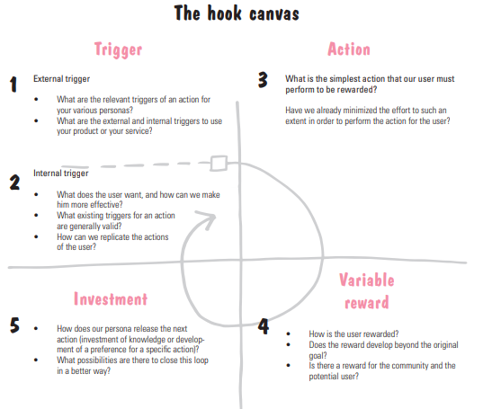
Image Source: The Design Thinking Playbook Book

Detailed Breakdown: The Hook Canvas
Phase | Component | Key Strategic Questions
1. Trigger | 1.1 External Trigger | What are the relevant triggers of an action for your various personas? What are the external and internal triggers to use your product or your service?
 | 1.2 Internal Trigger | What does the user want, and how can we make him more effective? What existing triggers for an action are generally valid? How can we replicate the actions of the user?
2. Action | Core Interaction | What is the simplest action that our user must perform to be rewarded? Have we already minimized the effort to such an extent in order to perform the action for the user?
3. Variable Rewards | Feedback Loop | How is the user rewarded? Does the reward develop beyond the original goal? Is there a reward for the community and the potential user?
4. Investment | Future Commitment | How does our persona release the next action (investment of knowledge or development of a preference for a specific action)? What possibilities are there to close this loop in a better way?

